How is it possible that there are thousands of computers which differ from one another, and yet they are able to run the same programs? Have you ever thought about how programs interact with the hardware? The answer is: we have **operating systems**.

**Operating system**

An operating system (OS)is a set of software that manages the communication between all other applications and hardware.It turns a computer into something more than just several metal parts, namely, a complex system that can perform different tasks effectively.

There are many operating systems. For personal computers, the most popular ones are Microsoft Windows, macOS, and Linux distributions. The two top mobile operating systems are Android and iOS. Even smart kettles and fridges have their own OS!

Of course, operating systems for such a range of devices are extremely diverse. What they have in common are the means they provide to the programs and to those who use them.

On the one hand, it's only an illusion that your favorite browser is the same on Windows as it is on macOS. On the other hand, you can run the same application on different computers with the same OS.

**OS functions**

An operating system controls the communication between the computer software and hardware. An OS can give programs restricted access to processor units, memory, hard drives, network, peripherals, and other resources.

You can run a browser, a media player, and ten other applications, and your OS is the one that allocates all the resources the applications need to run properly. At the same time, an OS acts as a fair referee and doesn't allow any application to use more resources than it actually needs.

As a mediator between the applications and hardware, an OS allows us to communicate with the device without going into details about its specifics or mechanics.

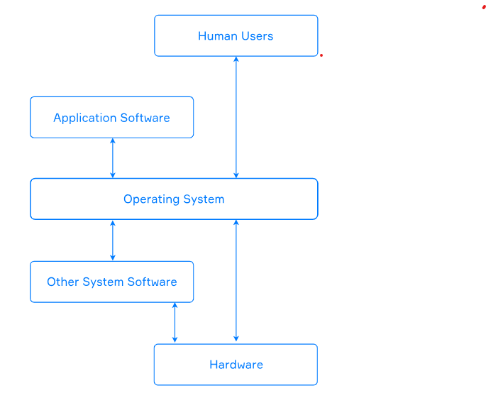

Any operating system has several essential functions. Here is a list of some of them:

* Data protection and secure access;
* Resource management;
* Interaction between hardware and peripherals;
* File management;
* Running other programs.

It is possible to distinguish more functions of modern operating systems, but those listed above are enough for starters.

**OS components**

The **kernel** is the mandatory and core part of all operating systems. Usually, it's one of the first programs that loads when you turn on your computer. It provides all the necessary means to run the programs you want.

When you start an OS, you often see the Graphical User Interface(GUI)**.**It is the interface that allows users to interact with the device using graphical icons and audio indicators. Another way to interact with the OS is to use commands in a text-based terminal known as the Command-Line Interface(CLI).

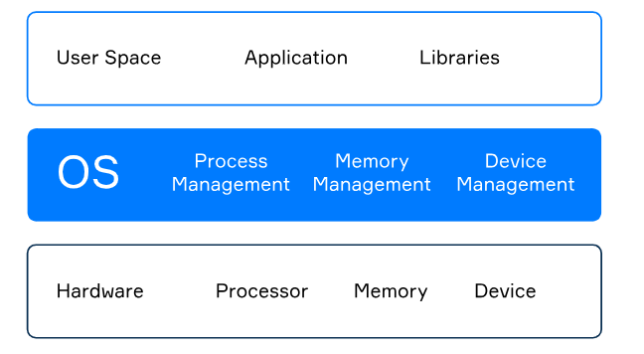There are two types of kernels: **monolithic** and **microkernels**. Amonolithic kernel is a large program that performs most of the OS functions. At the same time, amicrokernel performs only a small subset of the operating system functions, but we can extend it with additional modules known as **drivers**.

There are other important parts of the operating system besides the kernel and the graphical user interface. For now, use the following image to brush up on everything we've covered so far:

**Conclusion**

An operating system efficiently distributes the resources of the computer in the way we've described above. It is critical to understand that without an operating system, it would not be possible to use the computer.

Now you know about the main functions of operating systems and their essential elements. Let's test what you've learned so far!

Monolithic kernel is a program that performs most of the OS functions

Microkernel performs a smaller subset of the OS functions, can be extended with additional modules - drivers

Kernel is a mandatory part of any OS, it's core

User space Application and Libraries

Operating System Processor, Memory and Device management

Hardware Processor, Memory, Devices

## Riddle from Sphinx

Now, based on the theory try to answer a riddle from the famous Sphinx:

"A thing there is

whose types are two:

Large one of them

and many things can do,

Small second one

and do a few,

Important both are

from any point of view.

When you turn your computer on

It loads early, one of the first."